Mini Assignment 5: Hero & Villain - Inspiration & Reference

DIG2783

Dexavier Chang

9/21/2019

1.NARC

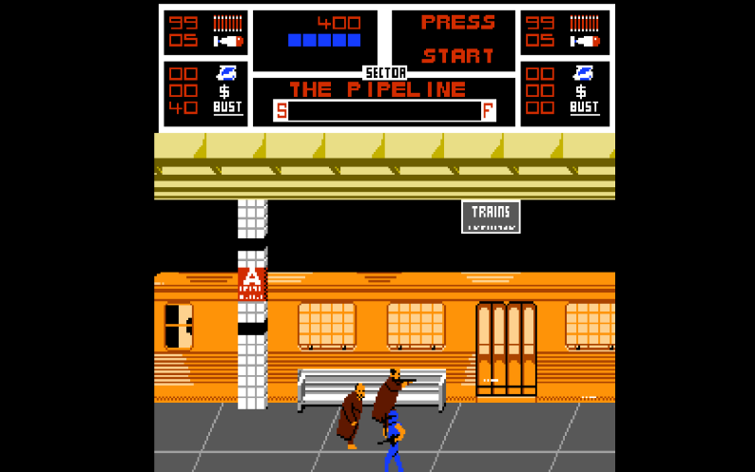

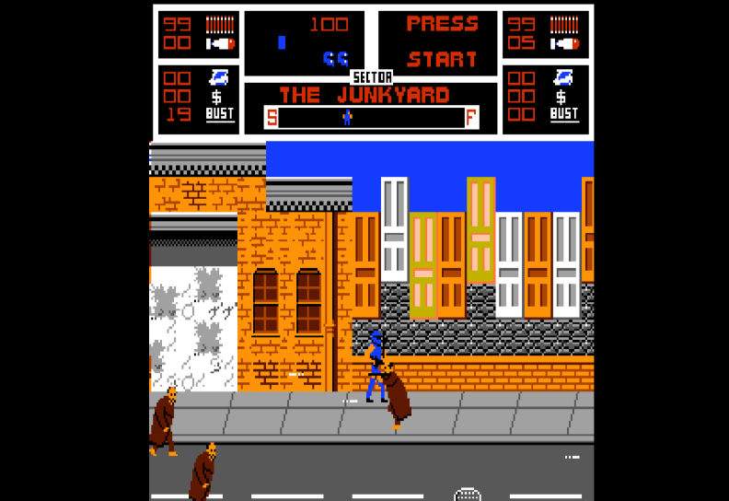

Like my on-going game, NARC includes a storyline rooted in the evils of drug dealing and its impact on society. The villains in NARC are typical drug pushers and lackeys who work for a boss named Mr. Big. The regular level villains in NARC are regular human beings with guns, bats, knives, and other combat weapons. I am basing my generic level villains off this influence.

2. Spider-Man: Return of the Sinister Six

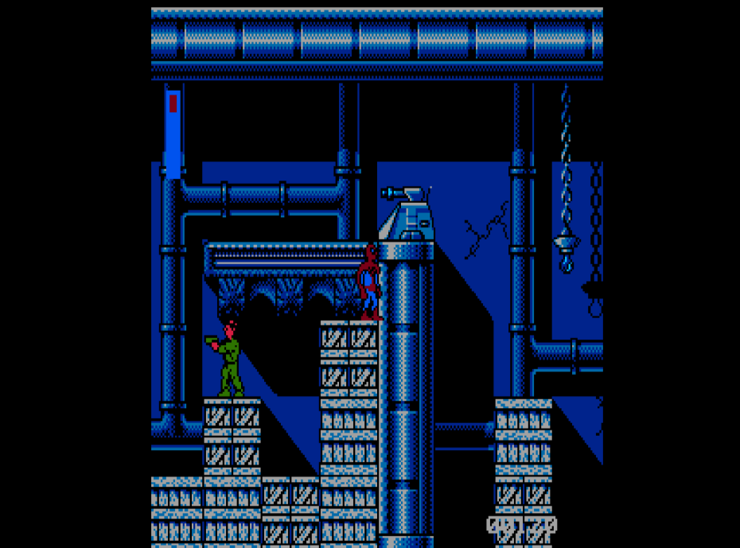

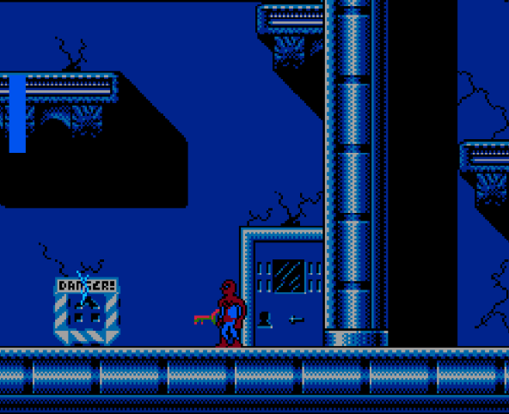

My main hero inspiration for my game is Spiderman, one of the greatest superheroes of all time. Aceman and Spiderman have many similarities between them like color and their respective storylines. Their storylines both deal with starting out as underdogs and eventually rising to take out a powerful threat.

3. Batman

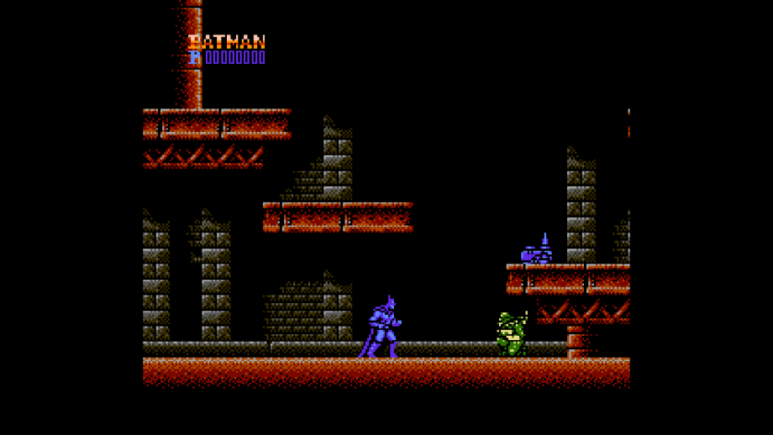

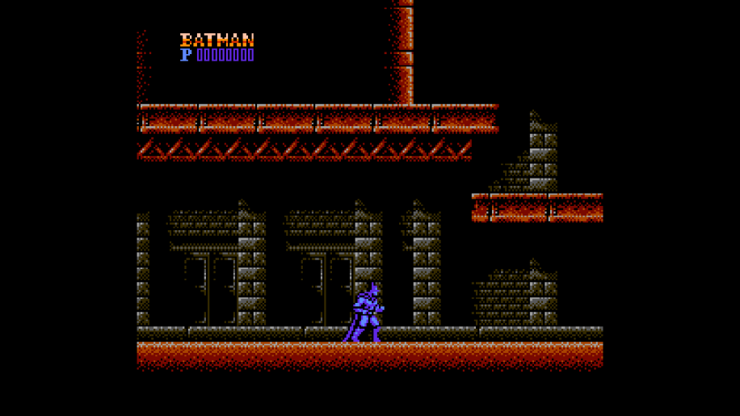

Batman is the second hero influence for my hero character. I say this because both depend on genius gadgets to save the day instead of super powers. That’s where their comparisons stop as Aceman doesn’t come from a rich background and uses street fighting techniques instead of a disciplined fighting style. As stated before, my influence comes from different types of heroes, not just Marvel or DC. I just felt that since these games featured the most popular heroes that it would be best to highlight them.